Prof R. Madana Mohana
BIG DATA ANALYTICS LAB
Exp-2. Develop the following application using Mapreduce

(ii) Analysis of Weather dataset on multinode cluster using Hadoop

Date: 01-02-2025

Running on Local File System:

hadoop@ubuntu22:~/Desktop/RMMBDALAB/MapReduce/Weather_Dataset$ ls

debug.log ncdc test_input.txt
instructions.txt temp-mapper.py 'waether_dataset mapredcue executed steps 01-02-2025.docx'
mapper_debug.log temp-reducer.py weather.txt

hadoop@ubuntu22:~/Desktop/RMMBDALAB/MapReduce/Weather_Dataset$

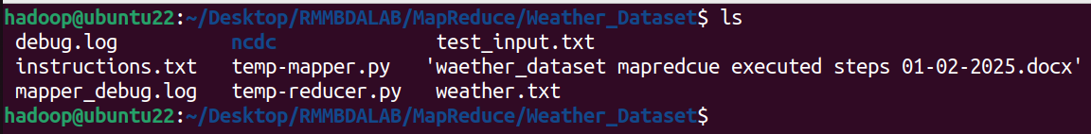
hadoop@ubuntu22:~/Desktop/RMMBDALAB/MapReduce/Weather_Dataset$ cat weather.txt

690190 13910 20060201_0 51.75 33.0 24 1006.3 24 943.9 24 15.0 24 10.7 24 22.0 28.9 0.00I 999.9 000000
690190 13910 20060201_1 54.74 33.0 24 1006.3 24 943.9 24 15.0 24 10.7 24 22.0 28.9 0.00I 999.9 000000
690190 13910 20060201_2 50.59 33.0 24 1006.3 24 943.9 24 15.0 24 10.7 24 22.0 28.9 0.00I 999.9 000000

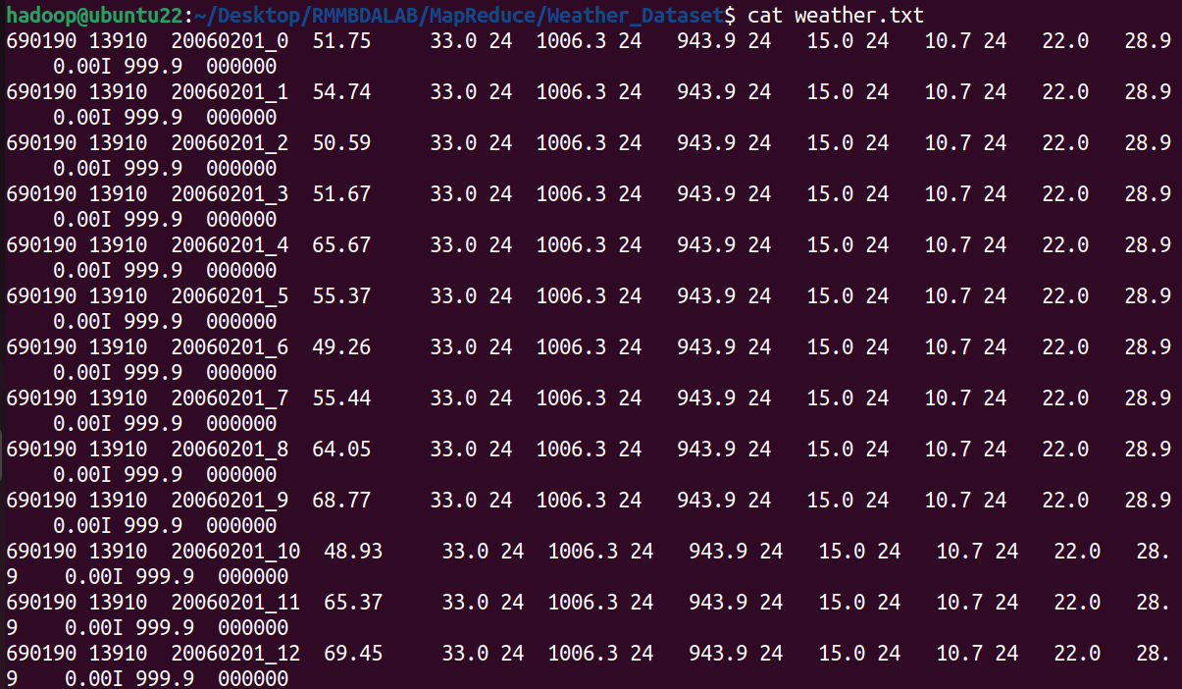

Running Mapper and Reducer code in local file systems using python:

hadoop@ubuntu22:~/Desktop/RMMBDALAB/MapReduce/Weather_Dataset$ cat weather.txt | python3 temp-mapper.py | sort | python3 temp-reducer.py

20060201 69.45
20060202 69.72
20060203 62.85
20060204 58.77

hadoop@ubuntu22:~/Desktop/RMMBDALAB/MapReduce/Weather_Dataset$

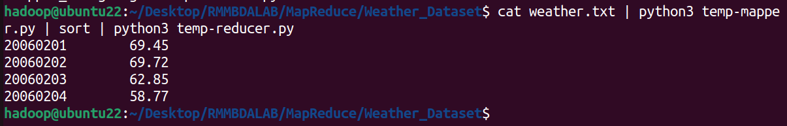

Running on Hadoop Cluster:

hadoop@ubuntu22:~/Desktop/RMMBDALAB/MapReduce/Weather_Dataset$

hadoop fs -mkdir /rmm_weather_data

hadoop@ubuntu22:~/Desktop/RMMBDALAB/MapReduce/Weather_Dataset$

hadoop fs -put weather.txt /rmm_weather_data

hadoop@ubuntu22:~/Desktop/RMMBDALAB/MapReduce/Weather_Dataset$ hadoop fs -ls /rmm_weather_data
Found 1 items
-rw-r--r-- 1 hadoop supergroup 12054 2025-02-01 10:43 /rmm_weather_data/weather.txt

hadoop@ubuntu22:~/Desktop/RMMBDALAB/MapReduce/Weather_Dataset$ hadoop jar /home/hadoop/hadoop/share/hadoop/tools/lib/hadoop-streaming-3.3.6.jar -file temp-mapper.py -mapper "python3 temp-mapper.py" -file temp-reducer.py -reducer "python3 temp-reducer.py" -input /rmm_weather_data -output /rmm_weather_data/weather_output

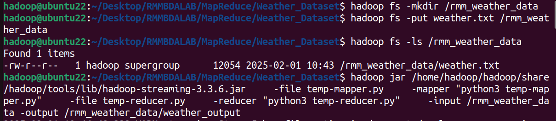

JOB Completions status:

Output Location:

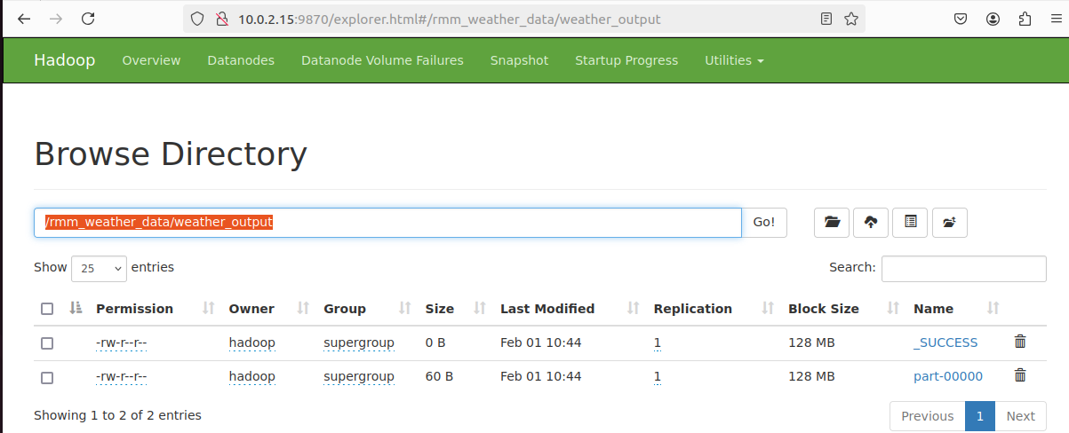
Output:

hadoop@ubuntu22:~/Desktop/RMMBDALAB/MapReduce/Weather_Dataset$

hadoop fs -ls /rmm_weather_data/weather_output

Found 2 items
-rw-r--r-- 1 hadoop supergroup 0 2025-02-01 10:44 /rmm_weather_data/weather_output/_SUCCESS
-rw-r--r-- 1 hadoop supergroup 60 2025-02-01 10:44 /rmm_weather_data/weather_output/part-00000

hadoop@ubuntu22:~/Desktop/RMMBDALAB/MapReduce/Weather_Dataset$ hadoop fs -cat /rmm_weather_data/weather_output/part-00000

20060201 69.45
20060202 69.72
20060203 62.85
20060204 58.77

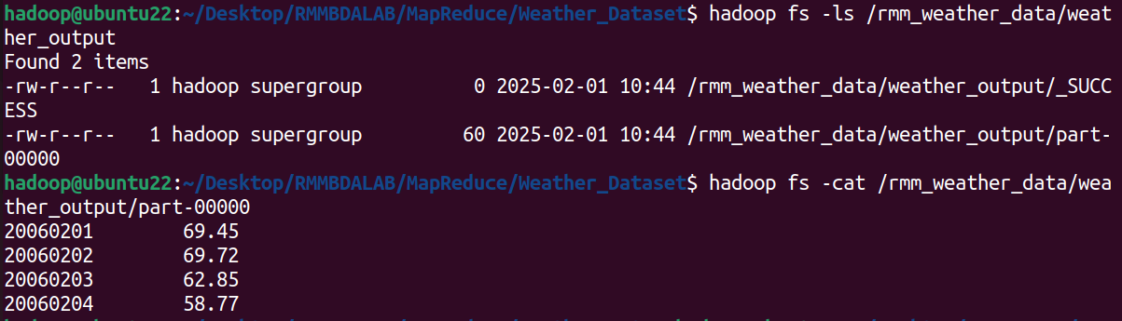
Source Files:

weather.txt:

690190 13910 20060201_0 51.75 33.0 24 1006.3 24 943.9 24 15.0 24 10.7 24 22.0 28.9 0.00I 999.9 000000
690190 13910 20060201_1 54.74 33.0 24 1006.3 24 943.9 24 15.0 24 10.7 24 22.0 28.9 0.00I 999.9 000000
690190 13910 20060201_2 50.59 33.0 24 1006.3 24 943.9 24 15.0 24 10.7 24 22.0 28.9 0.00I 999.9 000000
690190 13910 20060201_3 51.67 33.0 24 1006.3 24 943.9 24 15.0 24 10.7 24 22.0 28.9 0.00I 999.9 000000
690190 13910 20060201_4 65.67 33.0 24 1006.3 24 943.9 24 15.0 24 10.7 24 22.0 28.9 0.00I 999.9 000000
690190 13910 20060201_5 55.37 33.0 24 1006.3 24 943.9 24 15.0 24 10.7 24 22.0 28.9 0.00I 999.9 000000
690190 13910 20060201_6 49.26 33.0 24 1006.3 24 943.9 24 15.0 24 10.7 24 22.0 28.9 0.00I 999.9 000000
690190 13910 20060201_7 55.44 33.0 24 1006.3 24 943.9 24 15.0 24 10.7 24 22.0 28.9 0.00I 999.9 000000
690190 13910 20060201_8 64.05 33.0 24 1006.3 24 943.9 24 15.0 24 10.7 24 22.0 28.9 0.00I 999.9 000000
690190 13910 20060201_9 68.77 33.0 24 1006.3 24 943.9 24 15.0 24 10.7 24 22.0 28.9 0.00I 999.9 000000
690190 13910 20060201_10 48.93 33.0 24 1006.3 24 943.9 24 15.0 24 10.7 24 22.0 28.9 0.00I 999.9 000000
690190 13910 20060201_11 65.37 33.0 24 1006.3 24 943.9 24 15.0 24 10.7 24 22.0 28.9 0.00I 999.9 000000
690190 13910 20060201_12 69.45 33.0 24 1006.3 24 943.9 24 15.0 24 10.7 24 22.0 28.9 0.00I 999.9 000000
690190 13910 20060201_13 52.91 33.0 24 1006.3 24 943.9 24 15.0 24 10.7 24 22.0 28.9 0.00I 999.9 000000
690190 13910 20060201_14 53.69 33.0 24 1006.3 24 943.9 24 15.0 24 10.7 24 22.0 28.9 0.00I 999.9 000000
690190 13910 20060201_15 53.30 33.0 24 1006.3 24 943.9 24 15.0 24 10.7 24 22.0 28.9 0.00I 999.9 000000
690190 13910 20060201_16 66.17 33.0 24 1006.3 24 943.9 24 15.0 24 10.7 24 22.0 28.9 0.00I 999.9 000000
690190 13910 20060201_17 53.83 33.0 24 1006.3 24 943.9 24 15.0 24 10.7 24 22.0 28.9 0.00I 999.9 000000
690190 13910 20060201_18 50.54 33.0 24 1006.3 24 943.9 24 15.0 24 10.7 24 22.0 28.9 0.00I 999.9 000000
690190 13910 20060201_19 50.27 33.0 24 1006.3 24 943.9 24 15.0 24 10.7 24 22.0 28.9 0.00I 999.9 000000
690190 13910 20060201_20 59.08 33.0 24 1006.3 24 943.9 24 15.0 24 10.7 24 22.0 28.9 0.00I 999.9 000000
690190 13910 20060201_21 53.05 33.0 24 1006.3 24 943.9 24 15.0 24 10.7 24 22.0 28.9 0.00I 999.9 000000
690190 13910 20060201_22 57.97 33.0 24 1006.3 24 943.9 24 15.0 24 10.7 24 22.0 28.9 0.00I 999.9 000000
690190 13910 20060201_23 48.23 33.0 24 1006.3 24 943.9 24 15.0 24 10.7 24 22.0 28.9 0.00I 999.9 000000
690190 13910 20060202_0 47.16 28.5 24 1003.2 24 940.6 24 15.0 24 5.7 24 12.0 999.9 0.00I 999.9 000000
690190 13910 20060202_1 69.72 28.5 24 1003.2 24 940.6 24 15.0 24 5.7 24 12.0 999.9 0.00I 999.9 000000
690190 13910 20060202_2 62.71 28.5 24 1003.2 24 940.6 24 15.0 24 5.7 24 12.0 999.9 0.00I 999.9 000000
690190 13910 20060202_3 46.34 28.5 24 1003.2 24 940.6 24 15.0 24 5.7 24 12.0 999.9 0.00I 999.9 000000
690190 13910 20060202_4 53.15 28.5 24 1003.2 24 940.6 24 15.0 24 5.7 24 12.0 999.9 0.00I 999.9 000000
690190 13910 20060202_5 64.59 28.5 24 1003.2 24 940.6 24 15.0 24 5.7 24 12.0 999.9 0.00I 999.9 000000
690190 13910 20060202_6 58.26 28.5 24 1003.2 24 940.6 24 15.0 24 5.7 24 12.0 999.9 0.00I 999.9 000000
690190 13910 20060202_7 53.27 28.5 24 1003.2 24 940.6 24 15.0 24 5.7 24 12.0 999.9 0.00I 999.9 000000
690190 13910 20060202_8 43.68 28.5 24 1003.2 24 940.6 24 15.0 24 5.7 24 12.0 999.9 0.00I 999.9 000000
690190 13910 20060202_9 65.70 28.5 24 1003.2 24 940.6 24 15.0 24 5.7 24 12.0 999.9 0.00I 999.9 000000
690190 13910 20060202_10 66.27 28.5 24 1003.2 24 940.6 24 15.0 24 5.7 24 12.0 999.9 0.00I 999.9 000000
690190 13910 20060202_11 53.05 28.5 24 1003.2 24 940.6 24 15.0 24 5.7 24 12.0 999.9 0.00I 999.9 000000
690190 13910 20060202_12 68.45 28.5 24 1003.2 24 940.6 24 15.0 24 5.7 24 12.0 999.9 0.00I 999.9 000000
690190 13910 20060202_13 49.03 28.5 24 1003.2 24 940.6 24 15.0 24 5.7 24 12.0 999.9 0.00I 999.9 000000
690190 13910 20060202_14 66.59 28.5 24 1003.2 24 940.6 24 15.0 24 5.7 24 12.0 999.9 0.00I 999.9 000000
690190 13910 20060202_15 63.12 28.5 24 1003.2 24 940.6 24 15.0 24 5.7 24 12.0 999.9 0.00I 999.9 000000
690190 13910 20060202_16 49.13 28.5 24 1003.2 24 940.6 24 15.0 24 5.7 24 12.0 999.9 0.00I 999.9 000000
690190 13910 20060202_17 62.85 28.5 24 1003.2 24 940.6 24 15.0 24 5.7 24 12.0 999.9 0.00I 999.9 000000
690190 13910 20060202_18 64.67 28.5 24 1003.2 24 940.6 24 15.0 24 5.7 24 12.0 999.9 0.00I 999.9 000000
690190 13910 20060202_19 55.73 28.5 24 1003.2 24 940.6 24 15.0 24 5.7 24 12.0 999.9 0.00I 999.9 000000
690190 13910 20060202_20 56.42 28.5 24 1003.2 24 940.6 24 15.0 24 5.7 24 12.0 999.9 0.00I 999.9 000000
690190 13910 20060202_21 53.83 28.5 24 1003.2 24 940.6 24 15.0 24 5.7 24 12.0 999.9 0.00I 999.9 000000
690190 13910 20060202_22 45.14 28.5 24 1003.2 24 940.6 24 15.0 24 5.7 24 12.0 999.9 0.00I 999.9 000000
690190 13910 20060202_23 68.18 28.5 24 1003.2 24 940.6 24 15.0 24 5.7 24 12.0 999.9 0.00I 999.9 000000
690190 13910 20060203_0 48.41 26.5 24 1008.7 24 946.0 24 15.0 24 9.6 24 17.1 22.0 0.00I 999.9 000000
690190 13910 20060203_1 55.12 26.5 24 1008.7 24 946.0 24 15.0 24 9.6 24 17.1 22.0 0.00I 999.9 000000
690190 13910 20060203_2 46.48 26.5 24 1008.7 24 946.0 24 15.0 24 9.6 24 17.1 22.0 0.00I 999.9 000000
690190 13910 20060203_3 54.99 26.5 24 1008.7 24 946.0 24 15.0 24 9.6 24 17.1 22.0 0.00I 999.9 000000
690190 13910 20060203_4 50.62 26.5 24 1008.7 24 946.0 24 15.0 24 9.6 24 17.1 22.0 0.00I 999.9 000000
690190 13910 20060203_5 55.81 26.5 24 1008.7 24 946.0 24 15.0 24 9.6 24 17.1 22.0 0.00I 999.9 000000
690190 13910 20060203_6 59.28 26.5 24 1008.7 24 946.0 24 15.0 24 9.6 24 17.1 22.0 0.00I 999.9 000000
690190 13910 20060203_7 60.55 26.5 24 1008.7 24 946.0 24 15.0 24 9.6 24 17.1 22.0 0.00I 999.9 000000
690190 13910 20060203_8 52.62 26.5 24 1008.7 24 946.0 24 15.0 24 9.6 24 17.1 22.0 0.00I 999.9 000000
690190 13910 20060203_9 62.27 26.5 24 1008.7 24 946.0 24 15.0 24 9.6 24 17.1 22.0 0.00I 999.9 000000
690190 13910 20060203_10 49.90 26.5 24 1008.7 24 946.0 24 15.0 24 9.6 24 17.1 22.0 0.00I 999.9 000000
690190 13910 20060203_11 45.12 26.5 24 1008.7 24 946.0 24 15.0 24 9.6 24 17.1 22.0 0.00I 999.9 000000
690190 13910 20060203_12 62.85 26.5 24 1008.7 24 946.0 24 15.0 24 9.6 24 17.1 22.0 0.00I 999.9 000000
690190 13910 20060203_13 50.90 26.5 24 1008.7 24 946.0 24 15.0 24 9.6 24 17.1 22.0 0.00I 999.9 000000
690190 13910 20060203_14 49.73 26.5 24 1008.7 24 946.0 24 15.0 24 9.6 24 17.1 22.0 0.00I 999.9 000000
690190 13910 20060203_15 47.28 26.5 24 1008.7 24 946.0 24 15.0 24 9.6 24 17.1 22.0 0.00I 999.9 000000
690190 13910 20060203_16 46.67 26.5 24 1008.7 24 946.0 24 15.0 24 9.6 24 17.1 22.0 0.00I 999.9 000000
690190 13910 20060203_17 49.48 26.5 24 1008.7 24 946.0 24 15.0 24 9.6 24 17.1 22.0 0.00I 999.9 000000
690190 13910 20060203_18 59.53 26.5 24 1008.7 24 946.0 24 15.0 24 9.6 24 17.1 22.0 0.00I 999.9 000000
690190 13910 20060203_19 59.49 26.5 24 1008.7 24 946.0 24 15.0 24 9.6 24 17.1 22.0 0.00I 999.9 000000
690190 13910 20060203_20 52.25 26.5 24 1008.7 24 946.0 24 15.0 24 9.6 24 17.1 22.0 0.00I 999.9 000000
690190 13910 20060203_21 57.67 26.5 24 1008.7 24 946.0 24 15.0 24 9.6 24 17.1 22.0 0.00I 999.9 000000
690190 13910 20060203_22 54.04 26.5 24 1008.7 24 946.0 24 15.0 24 9.6 24 17.1 22.0 0.00I 999.9 000000
690190 13910 20060203_23 58.76 26.5 24 1008.7 24 946.0 24 15.0 24 9.6 24 17.1 22.0 0.00I 999.9 000000
690190 13910 20060204_0 48.60 15.6 24 1020.0 24 955.9 24 15.0 24 5.1 24 11.1 15.9 0.00I 999.9 000000
690190 13910 20060204_1 50.54 15.6 24 1020.0 24 955.9 24 15.0 24 5.1 24 11.1 15.9 0.00I 999.9 000000
690190 13910 20060204_2 38.55 15.6 24 1020.0 24 955.9 24 15.0 24 5.1 24 11.1 15.9 0.00I 999.9 000000
690190 13910 20060204_3 50.14 15.6 24 1020.0 24 955.9 24 15.0 24 5.1 24 11.1 15.9 0.00I 999.9 000000
690190 13910 20060204_4 34.86 15.6 24 1020.0 24 955.9 24 15.0 24 5.1 24 11.1 15.9 0.00I 999.9 000000
690190 13910 20060204_5 35.38 15.6 24 1020.0 24 955.9 24 15.0 24 5.1 24 11.1 15.9 0.00I 999.9 000000
690190 13910 20060204_6 41.52 15.6 24 1020.0 24 955.9 24 15.0 24 5.1 24 11.1 15.9 0.00I 999.9 000000
690190 13910 20060204_7 42.28 15.6 24 1020.0 24 955.9 24 15.0 24 5.1 24 11.1 15.9 0.00I 999.9 000000
690190 13910 20060204_8 45.11 15.6 24 1020.0 24 955.9 24 15.0 24 5.1 24 11.1 15.9 0.00I 999.9 000000
690190 13910 20060204_9 51.01 15.6 24 1020.0 24 955.9 24 15.0 24 5.1 24 11.1 15.9 0.00I 999.9 000000
690190 13910 20060204_10 43.60 15.6 24 1020.0 24 955.9 24 15.0 24 5.1 24 11.1 15.9 0.00I 999.9 000000
690190 13910 20060204_11 50.12 15.6 24 1020.0 24 955.9 24 15.0 24 5.1 24 11.1 15.9 0.00I 999.9 000000
690190 13910 20060204_12 55.07 15.6 24 1020.0 24 955.9 24 15.0 24 5.1 24 11.1 15.9 0.00I 999.9 000000
690190 13910 20060204_13 43.24 15.6 24 1020.0 24 955.9 24 15.0 24 5.1 24 11.1 15.9 0.00I 999.9 000000
690190 13910 20060204_14 49.84 15.6 24 1020.0 24 955.9 24 15.0 24 5.1 24 11.1 15.9 0.00I 999.9 000000
690190 13910 20060204_15 44.42 15.6 24 1020.0 24 955.9 24 15.0 24 5.1 24 11.1 15.9 0.00I 999.9 000000
690190 13910 20060204_16 58.77 15.6 24 1020.0 24 955.9 24 15.0 24 5.1 24 11.1 15.9 0.00I 999.9 000000
690190 13910 20060204_17 35.32 15.6 24 1020.0 24 955.9 24 15.0 24 5.1 24 11.1 15.9 0.00I 999.9 000000
690190 13910 20060204_18 34.83 15.6 24 1020.0 24 955.9 24 15.0 24 5.1 24 11.1 15.9 0.00I 999.9 000000
690190 13910 20060204_19 51.72 15.6 24 1020.0 24 955.9 24 15.0 24 5.1 24 11.1 15.9 0.00I 999.9 000000
690190 13910 20060204_20 52.39 15.6 24 1020.0 24 955.9 24 15.0 24 5.1 24 11.1 15.9 0.00I 999.9 000000
690190 13910 20060204_21 57.54 15.6 24 1020.0 24 955.9 24 15.0 24 5.1 24 11.1 15.9 0.00I 999.9 000000
690190 13910 20060204_22 50.37 15.6 24 1020.0 24 955.9 24 15.0 24 5.1 24 11.1 15.9 0.00I 999.9 000000
690190 13910 20060204_23 51.75 15.6 24 1020.0 24 955.9 24 15.0 24 5.1 24 11.1 15.9 0.00I 999.9 000000

Mapper Python Code: temp-mapper.py

#!/usr/bin/env python3

import sys

def mapper():
for line in sys.stdin:
parts = line.split()
if len(parts) < 5:
continue
date = parts[2].split('_')[0] # Extract the date part (YYYYMMDD)
try:
temp = float(parts[3]) # Extract the temperature
except ValueError:
continue
print(f"{date}\t{temp}")

if __name__ == "__main__":
mapper()

Reducer Python Code: temp-reducer.py

#!/usr/bin/env python3

import sys
from collections import defaultdict

def reducer():
current_key = None
max_temp = float('-inf')

for line in sys.stdin:
key, temp = line.strip().split('\t')
temp = float(temp)

if key != current_key:
if current_key:
print(f"{current_key}\t{max_temp}")
current_key = key
max_temp = temp
else:
max_temp = max(max_temp, temp)

if current_key:
print(f"{current_key}\t{max_temp}")

if __name__ == "__main__":
reducer()

